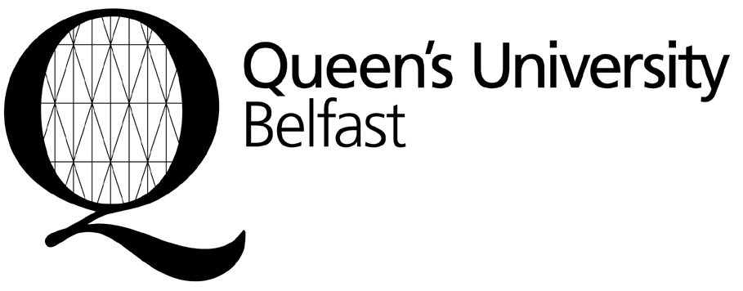
Income and Student Finance Office

Finance Directorate
Student Guidance Centre
Queen’s University Belfast
BELFAST
BT7 1NN
Northern Ireland
United Kingdom
incomeoffice@qub.ac.uk

Early Bird Payment Form (Appendix 2)

This form is to be used by students who have accepted an unconditional offer of a place on a postgraduate taught course, and who wish to pay 90% of the normal tuition fee in advance, thus receiving a 10% fee reduction as follows:

Tuition Fee | Value of Early Bird Reward  (10% of fee) | Net Fee to be paid in full to benefit from Early Payment Reward (ie. 90% of fee)
Band 1 courses: £11,266 | £1,126 | £10,140
Band 2 courses: £14,460 | £1,446 | £13,014

Payment must be received by the University on or before 15 August 2012.

If you require a receipt, you should complete all sections of this form and send, along with a copy of your offer letter, to the address above. If you do not send this form with full details, we will not be able to supply a receipt. You can enclose the receipt as proof of payment with your application for a student visa. Payment may be made by bank draft drawn on a UK bank, bank transfer, or credit card. If paying by bank draft, please attach this form to the draft.

Family Name:

Given Name:

Date of Birth:

Nationality:

Course qualification:
MSc |  |  | MA |  |  | LLM |  |  | Graduate Diploma |  |  | MSSc
(please tick box)

Course Title:

Student application number:
(Check your offer letter)

Address:

Email:

I wish to pay the following Net Fee (90% of normal tuition fee) to qualify for the 10% Early Payment Reward
(please tick one box)
£10,140
£13,014

Signed: …………….………………………………………………………………… Date: ……………………………………..

Once the University has received your payment, a receipt will be sent to the address given.

